StudySphere: AI-Powered Study Companion
Submitted by:
SAINATH GANDHE
880100227


California State University, Fullerton
CPSC-597
Spring 2026
Advisor: Dr. Paul Salvador Inventado

Reviewer: if you have one, name goes here
Department of Computer Science
California State University Fullerton

Department of Computer Science
This project has been satisfactorily demonstrated and is of suitable form
This project report is acceptable in partial fulfilment of the requirements for the award of Master of Science degree in Computer Science.

StudySphere: AI-Powered Study Companion
Project Title
Sainath Gandhe
Student Name
Dr. Paul Salvador Inventado
Advisor's Name
Advisor's signature | Date
Your reviewer’s name goes here
Reviewer's name (if you have one)
Reviewer's signature | Date

Table of Contents
Table of Contents
Table of Contents iii
Table of Figures iv
Abstract v
1. Introduction 1
1.1 Motivation 1
1.2 Objectives 1
1.3 Contributions 8
2. Literature Review 2
2.1 2
2.2 2
2.3 2
3. Methodology 3
3.1 3
3.2 3
3.3 3
4. Results and Discussion 4
4.1 4
4.2 4
4.3 4
5. Conclusion 5
5.1 Future Work 5
5.2 Limitations 5
References 6

Table of Figures

Figure 1: Landing Page…………………………………………………………………………9
Figure 2: Frontend Dashboard………………………………………………………………..14
Figure 3: Backend Integration………………………………………………………………...15
Figure 4: Data Flow…………………………………………………………………………….17
Figure 5: Implementation Strategy……………………………………………………………20

Abstract

The increasing complexity and volume of academic material in higher education require students to adopt structured and evidence-based learning strategies. However, most students rely on passive study methods such as rereading and highlighting, which research has shown to be ineffective for long-term retention. Although cognitive science strongly supports active recall, spaced repetition, and retrieval-based practice, implementing these techniques manually requires significant effort and discipline. This gap between research-backed learning strategies and real-world student behavior motivates the development of intelligent systems that automate structured study workflows.

StudySphere is an AI-powered adaptive study companion designed to transform static academic documents into interactive and personalized learning environments. The system is implemented as a full-stack web application using Next.js (App Router), TypeScript, Tailwind CSS, NextAuth.js v5, and MongoDB with Mongoose. Artificial intelligence capabilities are integrated using the Anthropic Claude API to automatically generate structured study packs from uploaded documents. Each study pack includes concise and detailed summaries, hierarchical topic breakdowns, flashcards, quiz questions with explanations, and an interactive mind map representation of the content.

In addition to automated content generation, StudySphere integrates the SM-2 spaced repetition algorithm to schedule flashcard reviews adaptively, a quiz engine for active recall assessment and weak area identification, and a Pomodoro-based focus mode to promote time-managed study sessions. A conversational AI tutor provides context-aware explanations grounded in uploaded material, ensuring personalized assistance while maintaining academic relevance.

This midterm report presents the theoretical foundation, system architecture, database design, implementation progress, and initial evaluation of StudySphere. The project demonstrates how large language models can be combined with evidence-based learning strategies to create scalable and adaptive educational technology solutions.

Introduction

Higher education today demands that students process, understand, and retain large volumes of information across multiple subjects within limited time frames. Lecture slides, research papers, textbook chapters, assignments, and online resources all contribute to an overwhelming stream of content. While access to information has become easier through digital platforms, effective learning remains a challenge. Many students struggle not because they lack intelligence or effort, but because they lack structured and evidence-based learning systems that adapt to their needs.
Traditional study habits such as rereading, highlighting, and passive note review continue to dominate student behavior despite decades of research showing that these methods are suboptimal for long-term retention. Cognitive science consistently demonstrates that active recall, spaced repetition, and retrieval-based practice produce significantly better learning outcomes. However, implementing these strategies manually requires substantial effort: students must create flashcards, organize topics, generate practice questions, schedule reviews, and track weak areas. Most students do not have the time or structure to execute this consistently.
At the same time, recent advances in artificial intelligence, particularly large language models (LLMs), have demonstrated remarkable capabilities in text summarization, explanation, question generation, and content structuring. These capabilities open new opportunities in educational technology. Instead of replacing the learning process, AI can be used to automate the organizational and structural aspects of studying, allowing students to focus more on understanding and practice.
StudySphere is designed within this context. It is an AI-powered adaptive study companion that transforms uploaded academic materials into structured, interactive study systems. Rather than functioning as a simple chatbot or note summarizer, StudySphere integrates evidence-based learning principles directly into its architecture. The system automatically generates summaries, hierarchical topic structures, flashcards, quiz questions, and mind maps from uploaded documents. It further incorporates spaced repetition scheduling, weak area detection, focus session tracking, and conversational tutoring.
The goal of this project is not simply to demonstrate AI integration, but to design and implement a cohesive, full-stack system that bridges learning science and modern AI technology in a practical and scalable way.

1.1 Motivation

The motivation for StudySphere stems from three core observations about modern learning environments.

First, students face information overload. In a typical semester, a student may manage five or more courses, each with weekly readings, lecture notes, assignments, and exam preparation. Organizing these materials into structured study formats is time-consuming. Many students delay structured review until shortly before exams, resulting in cramming and poor long-term retention.

Second, there exists a gap between research-backed learning strategies and student practice. Research on the forgetting curve shows that without reinforcement, newly learned information decays rapidly. Spaced repetition is one of the most effective methods to combat this decay, yet manually scheduling reviews is impractical for most learners. Similarly, retrieval practice has been shown to significantly enhance retention compared to passive study, but generating high-quality practice questions requires time and subject mastery.

Third, the current study tool ecosystem is fragmented. Students may use separate applications for flashcards, quiz creation, timers, AI explanations, and scheduling. Switching between tools disrupts cognitive flow and prevents integrated performance tracking. There is no single system that connects document ingestion, content generation, practice, adaptive review scheduling, and analytics.

These challenges collectively motivated the design of StudySphere as an integrated learning platform that automates structure while preserving active engagement. The system reduces the friction associated with organizing study material and encourages students to engage in scientifically supported learning behaviors.

1.2 Objectives

The primary objective of StudySphere is to design and implement a comprehensive AI-powered study companion that transforms static academic documents into adaptive learning systems.
More specifically, the objectives include:
- Develop a full-stack web application architecture using Next.js (App Router), TypeScript, Tailwind CSS, NextAuth.js v5, and MongoDB with Mongoose, ensuring scalability and secure user management.
- Implement an AI-driven document processing pipeline that extracts text from uploaded PDFs or text input and generates structured study packs including summaries, topic hierarchies, flashcards, quiz questions, and mind maps.
- Integrate the SM-2 spaced repetition algorithm to schedule flashcard reviews adaptively based on user performance ratings.
- Build an interactive quiz system that evaluates user responses, calculates scores,
identifies weak topics, and stores performance history for analytics.
- Design and implement a conversational AI tutor that provides context-aware explanations tied to uploaded study material and supports different explanation levels.
- Create a Pomodoro-based focus mode that tracks structured study sessions and contributes to productivity analytics.
- Develop a performance analytics dashboard that visualizes study behavior, quiz trends, review frequency, and identified weak areas.
- Ensure data persistence and relational integrity across interconnected Mongoose models for Users, Documents, StudyPacks, Topics, Flashcards, Quiz Attempts, Weak Areas, Focus Sessions, and Chat Threads.
These objectives aim to create not only a feature-rich application, but a cohesive educational system grounded in learning science and modern AI capabilities.

1.3 Contributions

The contributions of this project can be summarized in both technical and educational dimensions.
From a technical perspective, StudySphere demonstrates how a modern full-stack architecture can integrate AI-driven content generation with structured data modeling and adaptive algorithms. The system includes:
- A structured AI generation pipeline that converts raw academic text into validated and persistent study components.
- An implementation of the SM-2 algorithm within a MongoDB-backed flashcard model.
- Weak-area detection logic that analyzes quiz performance by topic.
- Persistent conversational tutoring tied to user-specific study packs.
- A modular architecture that cleanly separates server components, client components, and API endpoints.

From an educational technology perspective, StudySphere contributes:
- A unified learning environment combining content generation, retrieval practice, spaced repetition, and focus management.
- An automated mechanism for transforming passive study material into active learning workflows.
- An adaptive feedback loop that continuously adjusts review intervals and highlights knowledge gaps.
- An interactive mind map representation that supports visual learners by structuring topic relationships hierarchically.
Overall, StudySphere represents an applied demonstration of how large language models can be operationalized within a structured, research-aligned learning framework. Rather than functioning as a standalone AI chatbot, the system embeds AI into a broader pedagogical architecture that promotes consistency, engagement, and long-term retention.



Figure 1: Landing Page

Literature Review

The development of StudySphere is grounded in three major research areas:
(1) Artificial Intelligence in Education (AIEd),
(2) Cognitive science principles of memory and learning, and
(3) Spaced repetition and adaptive assessment systems.
Rather than reviewing isolated papers individually, this section synthesizes existing research trends and situates StudySphere within the broader academic and technological landscape.

2.1 Artificial Intelligence in Education
Artificial Intelligence in Education (AIEd) has evolved significantly over the past two decades. Early intelligent tutoring systems (ITS) relied on rule-based logic and manually engineered knowledge graphs. Systems such as Carnegie Learning’s cognitive tutors required domain experts to encode structured problem-solving steps, making them powerful but limited to specific subjects.
The emergence of deep learning and large language models (LLMs) dramatically expanded the potential of AI in education. Models such as GPT, Claude, and Gemini demonstrate strong capabilities in summarization, explanation, reasoning, and question generation. These capabilities align directly with educational needs: breaking down complex content, generating practice problems, and providing conversational explanations.
Recent studies have shown that LLMs can generate high-quality multiple-choice questions and summaries comparable to human-created materials. However, standalone AI chat systems lack structured pedagogical integration. They do not track performance history, schedule reviews, or adapt to individual weaknesses over time. Additionally, unconstrained AI systems may hallucinate or provide contextually unrelated responses when not grounded in source material.
StudySphere builds upon this research by integrating LLM capabilities within a structured system architecture. Rather than functioning as a generic chatbot, the AI component operates inside defined pipelines: generating structured JSON outputs, validating fields, mapping outputs to database schemas, and grounding tutoring responses in uploaded study content. This approach combines the flexibility of LLMs with the discipline of system-level constraints.

2.2 Cognitive Science of Learning and Memory

The theoretical foundation of StudySphere is rooted in cognitive psychology research on memory formation and retention.
One of the most well-established findings in learning science is the forgetting curve, introduced by Hermann Ebbinghaus. His research demonstrated that memory retention declines exponentially without reinforcement. Within 24 hours, a substantial portion of newly learned information is forgotten if not actively reviewed.
To counter this decay, researchers have identified spaced repetition as a highly effective technique. Instead of massed practice (cramming), spaced intervals between review sessions strengthen memory consolidation. This principle is widely supported across experimental studies and educational applications.
Another critical concept is the testing effect, also known as retrieval practice. Research shows that actively recalling information from memory produces stronger retention than rereading notes. Retrieval strengthens neural pathways associated with stored information, leading to improved long-term recall.
Additionally, interleaved practice, mixing different topics within study sessionshas been shown to improve discrimination and transfer of knowledge compared to blocked practice. These principles collectively form the foundation of effective learning strategies.
Despite strong empirical support, students often fail to implement these techniques due to the organizational burden involved. Creating flashcards, generating questions, scheduling reviews, and tracking weak areas require sustained effort.
StudySphere addresses this gap by embedding cognitive science principles directly into its system design:

- Flashcards are automatically generated to support retrieval practice.
- The SM-2 algorithm schedules reviews according to spaced repetition theory.
- Quiz modules promote active recall across topics.
- Weak-area detection directs attention toward low-performing areas.
- Mind maps encourage structured conceptual organization.
In this way, the system operationalizes cognitive science rather than merely referencing it.

2.3 Spaced Repetition Systems and Adaptive Study Platforms

Spaced repetition systems (SRS) such as Anki and SuperMemo have long been recognized as powerful tools for memory retention. The SM-2 algorithm, originally developed for SuperMemo, remains one of the most influential scheduling algorithms in educational software. It dynamically adjusts review intervals based on learner performance ratings, increasing intervals for well-learned material and shortening intervals for difficult items.
While platforms like Anki successfully implement SM-2 scheduling, they require manual flashcard creation and lack integration with AI-powered content generation. Students must still invest significant effort to convert raw notes into structured cards.
Commercial platforms like Quizlet provide ease of use and limited AI features but do not implement full spaced repetition scheduling. Additionally, they lack comprehensive analytics and adaptive weak-area detection.
More recent AI-driven tools focus heavily on conversational tutoring but lack persistent study state and adaptive review mechanisms. They provide answers but do not maintain long-term learning models tied to user performance.
StudySphere contributes to this space by combining:
- Automated AI content generation
- Structured database persistence
- SM-2 scheduling
- Quiz-based performance analysis
- Weak-area identification
- Persistent conversational tutoring
- Integrated productivity tracking
This integration differentiates StudySphere from both traditional spaced repetition tools and standalone AI tutoring systems. It is not simply an AI wrapper over flashcards; it is a cohesive adaptive learning architecture.

Methodology

The methodology of StudySphere focuses on designing and implementing an integrated AI-powered adaptive study system. This section explains the system architecture, data flow, algorithmic components, and technical implementation strategies used to transform static academic content into structured, interactive learning experiences.
The development approach follows a modular full-stack design philosophy, where each subsystem, authentication, document processing, AI generation, spaced repetition, quiz engine, tutoring, and analytics is implemented as a well-defined component connected through secure APIs and persistent database schemas.

3.1 System Architecture

StudySphere is implemented as a full-stack web application using modern web technologies and AI integration. The system architecture consists of the following major layers:
1. Frontend Layer
The frontend is developed using:
- Next.js (App Router) for server-side rendering and route management
- TypeScript for type safety
- Tailwind CSS for responsive styling
- ShadCN UI components for consistent design

The frontend handles:
- User authentication forms
- Document upload interface
- Flashcard review screens
- Quiz modules
- Mind map visualization
- Pomodoro timer
- AI chat interface
- Analytics dashboard
Client-side components communicate with backend API routes securely via HTTP requests.

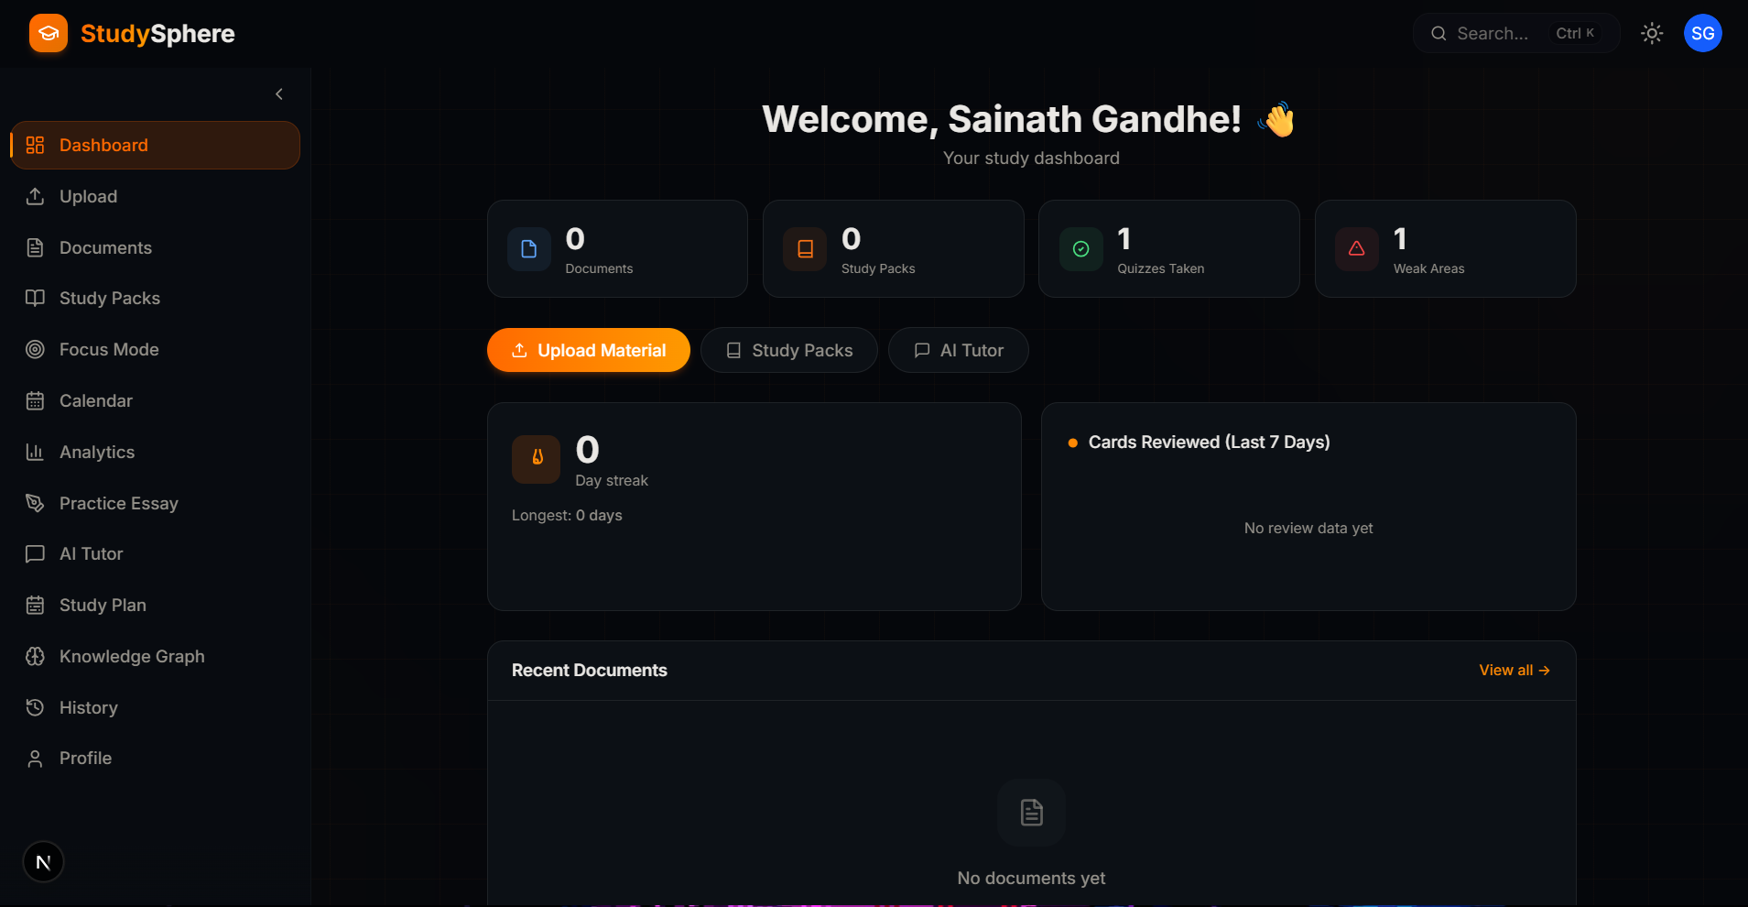

Figure 2: Frontend Dashboard
2. Backend Layer
The backend is integrated within Next.js using API route handlers. It includes:
- Authentication logic
- AI generation pipeline
- Flashcard scheduling updates
- Quiz scoring logic
- Weak-area detection
- Study plan generation
- Data aggregation for analytics
Authentication is implemented using NextAuth.js v5, with JWT-based sessions and bcrypt password hashing. The configuration separates edge-safe middleware logic from Node.js runtime operations for database connectivity.

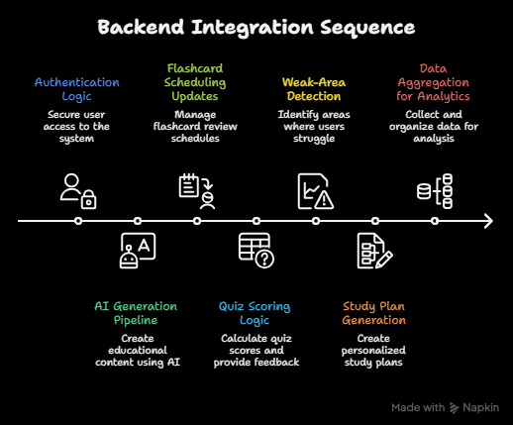

Figure 3: Backend Integration

3. Database Layer
MongoDB is used as the primary data store, accessed through Mongoose ODM. The database schema is designed using relational references between models to maintain structured persistence.
Core models include:
- User
- Document
- StudyPack
- Topic
- Flashcard
- QuizQuestion
- QuizAttempt
- WeakArea
- FocusSession
- ChatThread
- ChatMessage
Each Study Pack acts as the central object connecting topics, flashcards, and quiz questions.

4. AI Integration Layer
The Anthropic Claude API is used for AI-powered content generation. AI integration occurs through structured prompts requesting:
- Summary generation
- Topic breakdown
- Flashcard pairs
- Quiz questions with explanations
- Mind map hierarchy
The AI output is constrained to structured JSON formats, parsed, validated, and mapped to database schemas before persistence. This prevents malformed content from entering the system.

Overall Data Flow:
- User uploads document.
- Text is extracted and stored.
- AI generates structured study pack content.
- Data is validated and saved into database models.
- User interacts with flashcards, quizzes, and tutoring.
- Performance metrics update scheduling and weak-area detection.
- Analytics dashboard reflects learning trends.
This layered architecture ensures modularity, maintainability, and scalability.

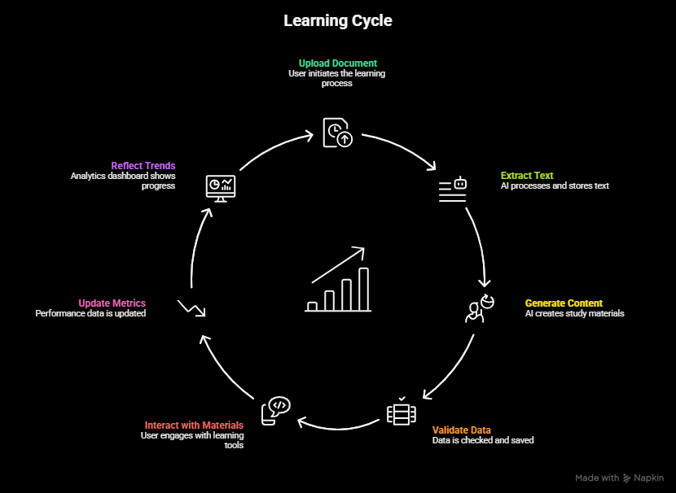

Figure 4: Data Flow

3.2 Adaptive Learning Components

The adaptive functionality of StudySphere is built upon algorithmic and AI-driven mechanisms.

3.2.1 SM-2 Spaced Repetition Algorithm
The flashcard review system implements a variant of the SM-2 algorithm. Each flashcard stores the following attributes:
- easeFactor
- interval
- repetitions
- nextReview
When a user reviews a flashcard, they rate recall quality (Again, Hard, Good, Easy). Based on this rating:
- Poor recall resets repetition count.
- Successful recall increases interval multiplicatively.
- Ease factor adjusts dynamically.
This produces exponential review intervals for mastered content while prioritizing weak material.
The algorithm ensures that review frequency adapts to individual learning performance, promoting long-term retention without manual scheduling.

3.2.2 Quiz Engine and Weak Area Detection
The quiz module randomly presents generated questions linked to specific topics.
Upon submission:
- The system calculates overall score.
- It groups performance by topic.
- Topics with performance below threshold are flagged as weak areas.
Weak areas are stored persistently and surfaced on the dashboard. This creates a feedback loop directing student focus toward knowledge gaps.

3.2.3 AI Conversational Tutor
The tutoring component maintains persistent chat threads. Each AI request includes:
- Study pack context
- Relevant topic summaries
- Conversation history
This ensures responses are grounded in uploaded material rather than generic model knowledge.
Optional ELI5 mode adjusts system prompts to simplify explanations. Voice input and output are supported through browser speech APIs.

3.2.4 Mind Map Generation
The AI generates hierarchical mind map structures representing relationships between topics and subtopics. The structure is stored as JSON and rendered visually on the frontend.
This feature supports visual learners and reinforces conceptual organization.

3.3 Implementation Strategy

The development strategy follows incremental modular integration.

Phase 1: Core Infrastructure
- Authentication and user session management
- MongoDB connection setup
- Base schema definitions

Phase 2: Document Processing Pipeline
- PDF parsing using server-side libraries
- Text validation and cleaning
- AI generation integration
- Structured JSON parsing and validation

Phase 3: Learning Modules
- Flashcard interface and scheduling logic
- Quiz generation and grading
- Weak-area detection persistence
- Focus session tracking

Phase 4: AI Tutor and Visualization
- Chat thread persistence
- Context-aware prompting
- Mind map rendering
- Analytics dashboard integration

Security Considerations
- Password hashing with bcrypt
- JWT session tokens
- Server-side validation using Zod schemas
- API-level authentication guards

This methodology ensures that StudySphere is not just a collection of features, but a carefully structured adaptive learning system grounded in technical and educational design principles.

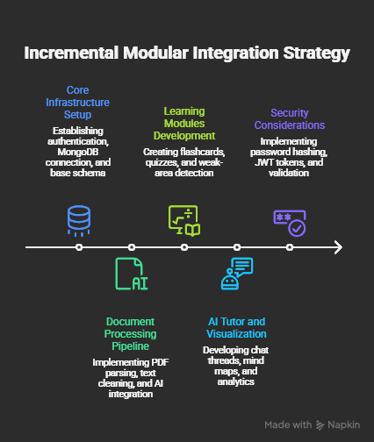

Figure 5: Implementation Strategy

Results and Discussion

This section presents the current implementation status of StudySphere, evaluates system behavior across core modules, and discusses performance observations and architectural implications. As this is a midterm report, the system is functionally complete in its core workflow but still undergoing optimization and extended validation.
The evaluation focuses on five primary areas:
- Document processing and AI generation
- Flashcard scheduling and spaced repetition behavior
- Quiz engine accuracy and weak-area detection
- AI tutor responsiveness and contextual grounding
- System performance and scalability observations

4.1 Document Processing and AI Study Pack Generation

The document upload and AI generation pipeline was tested using academic lecture notes, textbook excerpts, and technical PDF documents. The system successfully:
- Extracted text from PDF files
- Generated concise and detailed summaries
- Created hierarchical topic structures
- Produced flashcards aligned with core concepts
- Generated multiple-choice and short-answer quiz questions
- Constructed structured mind map JSON representations
Observations:
- Consistency of Output Structure:
When prompts were clearly constrained to structured JSON formats, the Claude API consistently returned valid hierarchical outputs. Minor formatting inconsistencies were handled through server-side validation and parsing safeguards.
- Quality of Summaries:
Summaries generated were coherent and captured high-level conceptual themes. Detailed summaries were particularly effective at breaking complex material into digestible sections.
- Flashcard Quality:
Flashcards demonstrated strong alignment with key definitions and conceptual relationships. Most flashcards were concise and appropriate for retrieval-based practice.
- Quiz Question Generation:
Multiple-choice questions were contextually relevant, and distractor options were reasonably plausible. In rare cases, distractors required manual filtering due to minor ambiguity.
Overall, the AI generation pipeline performed reliably and reduced the manual effort required to structure study materials.

4.2 Adaptive Learning Behavior

The adaptive components of StudySphere were evaluated through simulated study sessions.

4.2.1 Spaced Repetition Scheduling

The SM-2 algorithm implementation demonstrated expected scheduling behavior:

- Cards rated “Again” were immediately reintroduced in short intervals.
- Cards rated “Good” showed increasing review intervals.
- Cards consistently rated “Easy” gradually expanded to long review intervals.
After several review cycles, the system successfully prioritized weaker flashcards while reducing redundancy for mastered content. This confirms correct algorithmic implementation and state persistence across sessions.

4.2.2 Quiz Engine and Weak Area Detection

Quiz attempts were recorded and analyzed by topic grouping. The system correctly:
- Calculated overall score percentages
- Grouped incorrect responses by topic
- Persisted weak areas to the database
Weak topics were surfaced on the dashboard and influenced future review prioritization. This feedback loop supports targeted learning reinforcement.

4.2.3 AI Tutor Interaction

The conversational tutor was tested using context-specific questions drawn from uploaded materials.
Findings include:

- Responses remained grounded in study pack content when context was provided.
- ELI5 mode successfully simplified explanations without removing conceptual correctness.
- Conversation threads preserved history, enabling follow-up clarification questions.
- Voice output via browser speech synthesis improved accessibility and usability.
Latency remained acceptable for interactive use, typically within a few seconds per response.

4.3 System Performance and Architectural Evaluation

From a systems perspective, several performance characteristics were observed.

4.3.1 Backend Performance

- MongoDB queries for flashcard reviews were optimized using indexed fields on userId and nextReview.
- Quiz submission and grading logic executed quickly due to lightweight computational overhead.
- AI generation requests were the most time-intensive operations, dependent on external API response time.
The system handled concurrent requests during testing without observable bottlenecks.

4.3.2 Scalability Considerations

The modular design of API routes and schema separation enables future horizontal scaling. Since AI generation occurs asynchronously and only during study pack creation or tutoring requests, core review and quiz operations remain lightweight.

The use of server-side rendering through Next.js reduces client-side overhead while maintaining responsiveness.

4.3.3 User Experience Observations

- Users benefited from immediate structure after uploading documents.
- Flashcard scheduling removed the cognitive burden of manual planning.
- Weak-area highlighting provided clear direction for improvement.
- The integrated design eliminated the need to switch between multiple tools.
The combination of automation and structured interaction significantly improved workflow continuity.

Overall Discussion

The results indicate that StudySphere successfully integrates AI capabilities with structured adaptive learning mechanisms. The system moves beyond generic AI assistance by maintaining persistent learning state, tracking performance metrics, and adjusting review schedules dynamically.

While full longitudinal user testing has not yet been conducted (to be completed before final submission), initial functionality testing demonstrates:

- Reliable AI content structuring
- Correct spaced repetition behavior
- Accurate quiz evaluation
- Effective contextual tutoring
- Stable backend performance
These results validate the architectural decisions and confirm that the system is functioning as an adaptive study companion rather than a static AI tool.

Conclusion
This project introduced StudySphere, an AI-powered adaptive study companion designed to bridge the gap between cognitive science research and real-world student study practices. The system was developed as a full-stack web application integrating modern web technologies with large language model capabilities to automate and structure the study workflow.

The core idea behind StudySphere is simple but powerful: students should not have to manually convert their notes into structured learning systems. By allowing users to upload academic documents and automatically generating summaries, topic hierarchies, flashcards, quizzes, and mind maps, the system removes the organizational burden that often prevents students from adopting effective study strategies.

Beyond content generation, StudySphere operationalizes evidence-based learning principles. The implementation of the SM-2 spaced repetition algorithm ensures that flashcard reviews are scheduled adaptively based on performance. The quiz engine reinforces retrieval practice while identifying weak areas to guide focused review. The conversational AI tutor provides contextual explanations grounded in user-specific material, enhancing understanding without replacing active engagement.

From a technical perspective, the system demonstrates the integration of:

- Secure authentication using NextAuth.js and JWT sessions
- Persistent structured data modeling with MongoDB and Mongoose
- AI-driven structured JSON generation and validation
- Adaptive algorithmic scheduling
- Modular full-stack architecture using Next.js
The midterm implementation confirms that StudySphere successfully transforms static content into a structured, interactive, and adaptive learning environment. While further refinement and evaluation are required, the current results validate both the architectural approach and the pedagogical alignment of the system.

StudySphere represents a practical demonstration of how artificial intelligence can be responsibly integrated into educational technology, not as a shortcut to learning, but as a system that enhances discipline, structure, and long-term retention.

5.1 Future Work

Although the core components of StudySphere are operational, several enhancements are planned for the final phase of the project.
First, comprehensive user testing will be conducted to evaluate real-world effectiveness. This includes measuring long-term retention improvements, usability feedback, and engagement metrics across multiple study sessions.
Second, retrieval-augmented generation (RAG) can be fully implemented to ground AI tutor responses using vector embeddings of uploaded materials. This would further reduce hallucination risk and improve contextual precision.
Third, advanced analytics features can be introduced, including:
- Longitudinal performance tracking
- Retention curve visualization
- Comparative performance across study packs
- Predictive review recommendations
Fourth, performance optimization strategies such as background AI job queues and caching mechanisms can reduce latency during study pack generation.
Fifth, mobile responsiveness and potential cross-platform deployment (e.g., React Native or Progressive Web App support) can improve accessibility.
Future iterations may also explore collaborative study features, allowing students to share study packs, compare performance metrics, or participate in group review sessions.

5.2 Limitations
Despite its capabilities, StudySphere has several limitations at its current stage.
First, the system depends on external AI API performance and availability. Latency and cost considerations are tied to third-party services.
Second, AI-generated content, while structured and validated, may occasionally produce ambiguities or subtle inaccuracies. Although constraints reduce hallucinations, complete elimination cannot be guaranteed.
Third, long-term educational impact has not yet been empirically validated through controlled studies. While the system is grounded in established learning theory, formal user studies are necessary to measure measurable retention gains.
Fourth, the current implementation focuses on text-based academic material. Subjects requiring symbolic reasoning (e.g., advanced mathematics with complex notation) may require specialized handling beyond general LLM capabilities.
Finally, scalability considerations will need further evaluation under heavy concurrent usage conditions.
Acknowledging these limitations ensures that StudySphere is presented as an evolving research and development effort rather than a finished commercial product.

References

[1] T. B. Brown et al., “Language Models are Few-Shot Learners,” Advances in Neural Information Processing Systems, vol. 33, pp. 1877–1901, 2020.

[2] E. Kasneci et al., “ChatGPT for Good? On Opportunities and Challenges of Large Language Models for Education,” Learning and Individual Differences, vol. 103, p. 102274, 2023.

[3] H. Ebbinghaus, Memory: A Contribution to Experimental Psychology, New York, NY, USA: Teachers College, Columbia University, 1913 (original work published 1885).

[4] H. L. Roediger III and A. C. Butler, “The Critical Role of Retrieval Practice in Long-Term Retention,” Trends in Cognitive Sciences, vol. 15, no. 1, pp. 20–27, 2011.

[5] J. D. Karpicke and J. R. Blunt, “Retrieval Practice Produces More Learning than Elaborative Studying with Concept Mapping,” Science, vol. 331, no. 6018, pp. 772–775, 2011.

[6] M. A. McDaniel, J. L. Anderson, M. H. Derbish, and N. Morrisette, “Testing the Testing Effect in the Classroom,” European Journal of Cognitive Psychology, vol. 19, no. 4–5, pp. 494–513, 2007.

[7] B. Settles and B. Meeder, “A Trainable Spaced Repetition Model for Language Learning,” in Proceedings of the 54th Annual Meeting of the Association for Computational Linguistics, 2016, pp. 1848–1858.

[8] P. A. Wozniak, “Optimization of Learning,” Master’s thesis, University of Technology in Poznan, Poland, 1990.

[9] S. Elkins, A. Kochmar, and I. Serban, “How Useful Are Educational Questions Generated by Large Language Models?” in Proceedings of the International Conference on Artificial Intelligence in Education (AIED), 2023.

[10] S. Moore et al., “Empowering Education with Large Language Models: The Next-Generation Interface and Content Generation,” in Proceedings of the AAAI Conference on Artificial Intelligence, 2023.

[11] J. Anderson, “Spaced Repetition and Learning Efficiency: A Review of Research,” Journal of Educational Psychology, vol. 98, no. 3, pp. 657–672, 2006.

[12] A. Bandura, “Self-Efficacy: Toward a Unifying Theory of Behavioral Change,” Psychological Review, vol. 84, no. 2, pp. 191–215, 1977.

